**Ridge View Secondary College**

**Humanities and Social Sciences**

**ANCIENT HISTORY 2024**

*GENERAL COURSE*

**YEAR 12 COURSE INFORMATION**

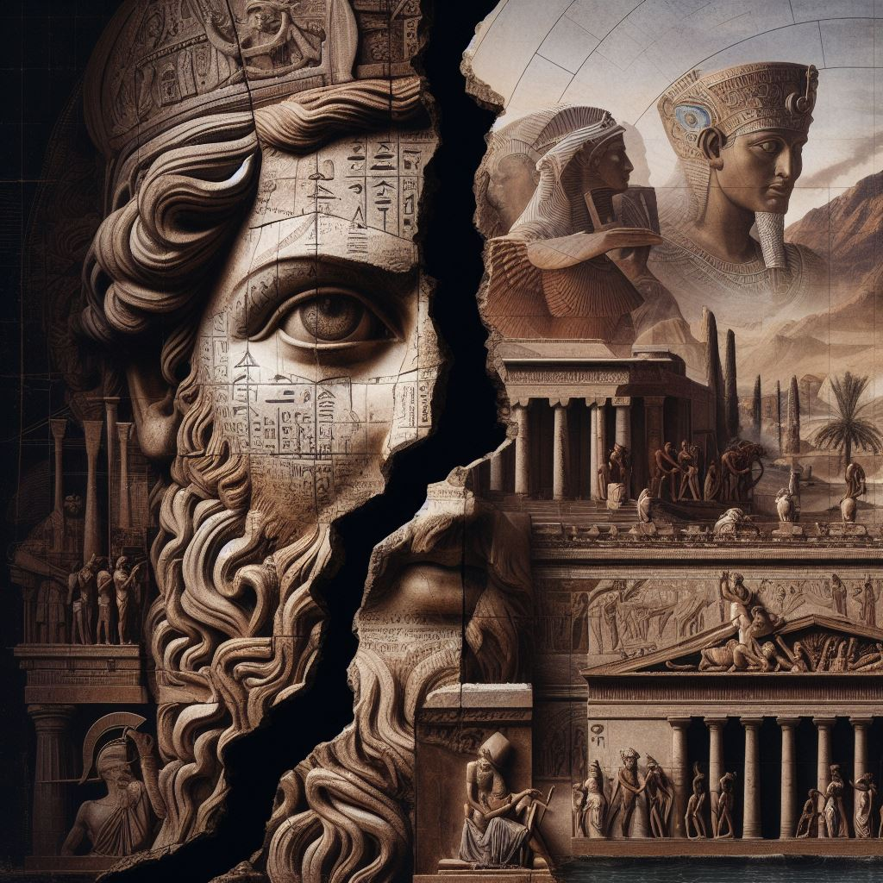

Teacher: Ms Lauren Barrie

Contact: [lauren.barrie@education.wa.edu.au](mailto:lauren.barrie@education.wa.edu.au)

**CONTENTS**

Contents…………………………………………………………………………………………………………………………………………….2

Important Documents and suggested books……………..…………………………………………………….………………..3

Unit 3 and Unit 4 Content from Syllabus ……………………………………..…………………………………………….……4 - 6

2024 Year 12 General Ancient History Unit 3 and 4 Program………………………………………………………..…7 - 10

2024 Year 12 General Ancient History Assessment Outline………….…………………………………....……………..11

EST Content…………..………………………………………….………….………………………………………..……………..…………..12

Maximising your achievement: Marking Guides………….…………………………………………………….…..……..13 – 17

Glossary of key terminology………………………………………….………….…………………………………………..…………..18

**IMPORTANT DOCUMENTS**

|  |  |  |
| --- | --- | --- |
| **Name of Document** | **Available** | |
| **In this   package** | **On   Compass** |
| 2024 WACE Manual |  | ✔️ |
| RVSC Senior School Assessment Policy |  | ✔️ |
| Year 12 General Ancient History Syllabus |  | ✔️ |
| Unit 3 and 4 Content from Syllabus | ✔️ | ✔️ |
| 2024 Year 12 General Ancient History Unit 3 and 4 Program (subject to change) | ✔️ | ✔️ |
| 2024 Year 12 General Ancient History Assessment Outline (subject to change) | ✔️ | ✔️ |
| 2024 Year 12 General Ancient History Support Resources | ✔️ | ✔️ |

**SUGGESTED BOOKS:**

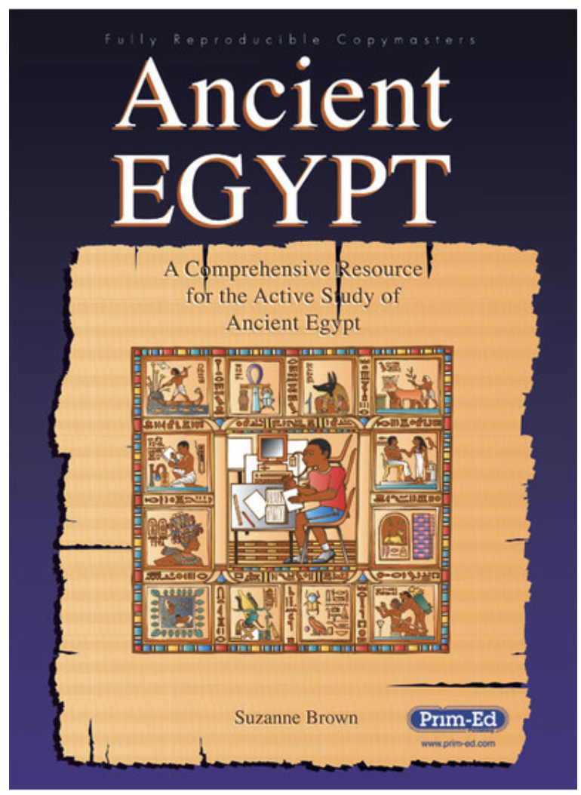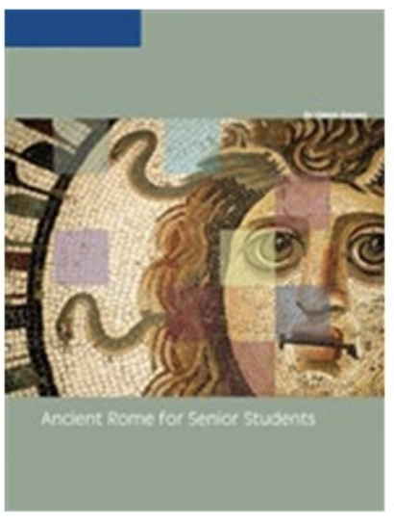

Ancient Egypt: A Comprehensive Resource for the active study of Ancient Egypt

Ancient Rome for Senior Students

**UNIT 3 AND 4 CONTENT  
FROM SYLLABUS**

# Unit 3 – Societies and Change

## Unit description

In this unit, students examine the evolving nature of societies and the various forces for continuity and change that exist. They also learn that values, beliefs and traditions are linked to the identity of a society. Students learn that in any period of change there are those individuals and/or groups that support change, but others that oppose it, and that there are different interpretations of the resultant society.

## Unit content

This unit includes the knowledge, understandings and skills described below.

### Historical Knowledge and Understanding

Students study **one** of the following electives, which is to be taught with the requisite historical skills described as part of this unit.

The elective studied must not be the same as those electives studied in Unit 1 or planned for Unit 4.

* ***Rome, the Late Republic to the Lex Manilia c. 133–66 BC***

The following themes should be considered, where appropriate, throughout the elective:

* military
* political
* social
* cultural
* religious
* economic.

Students investigate the chosen elective using the following framework:

**Elements of a society at the start of the period**

* broad overview of the historical context for the ancient society
* key political, social, religious, cultural, military and economic structures of the society at the start of the period
* values, beliefs and traditions that have evolved and/or become integral to the society
* individuals and groups who hold power and those who do not

**Key people, ideas and events of the period**

* key people, ideas and/or events and their influence on society
* the role of people, ideas and events as forces for change in the period
* examples of change in the period (political, social, religious, cultural, military and/or economic)
* examples of continuity in the period (political, social, religious, cultural, military and/or economic)
* methods and strategies used by leaders, individuals and/or groups seeking change
* leaders, individuals and/or groups that supported change and their reasons (motives) for doing so
* leaders, individuals and/or groups that resisted change and their reasons (motives) for doing so

**Effects of continuity and change in the period**

* short-term and long-term effects of change in the period
* evidence and impact of change on the lives of individuals and/or groups
* short-term and long-term effects of continuity in the period

# Unit 4 – Confrontation and Resolution

## Unit description

In this unit, students learn that there are internal and external forces that result in confrontation and resolution within societies, and these have consequences for continuity and change. Students assess how power is used, how different groups and individuals respond, and whether there is the potential for greater confrontation or more effective resolution to conflict.

## Unit content

Students study **one** of the following electives, which is to be taught with the requisite historical skills described as part of this unit.

The elective studied must not be the same as those electives studied in Unit 1 or Unit 3.

* ***Egypt, Akhenaten and the Amarna Revolution, Amenhotep IV/Akhenaten to the death of Horemheb c. 1352–c. 1295 BC***

The following themes should be considered, where appropriate, throughout the elective:

* military
* political
* social
* cultural
* religious
* economic.

Students investigate the chosen elective using the following framework:

### Elements of a society at the start of the period

* broad overview of the historical context for the ancient society
* key political, social, religious, cultural, military and economic structures of the society at the start of the period
* values, beliefs and traditions that were integral to the society and how these were challenged
* individuals and groups who hold power and those who do not

**Key people, ideas and events of the period**

* causes of confrontation in the period (internal and external forces)
* people, ideas and/or events that contributed to confrontation in the period
* people, ideas and/or events that contributed to resolution of conflict in the period
* means by which individuals and/or groups have gained power
* methods and strategies used by leaders, individuals and/or groups to achieve their aims

**Effects of confrontation and resolution for continuity and change in the period**

* short-term and long-term effects of confrontation for continuity and change
* short-term and long-term effects of resolution of conflict for continuity and change

# 

# Course Outline

**Semester 1 – Unit 3**

Societies and change

***Rome, the Late Republic to the Lex Manilia c. 133–66 BC***

|  |  |  |
| --- | --- | --- |
| **Timing** | **Syllabus Content** | **Assessments** |
| 1 | **Elements of society at the start of the period - Rome**   * broad overview of the historical context for the ancient society |  |
| 2 - 4 | **Elements of Roman society at the start of the period**   * key social and cultural features, structures * key political, social, religious, cultural, military and economic structures of the society at the start of the period * values, beliefs and traditions that have evolved and/or become integral to the society * individuals and groups who hold power and those who do not |  |
| 5 - 6 | **Key people, ideas and events of the period**   * key people, ideas and/or events and their influence on Roman society * the role of people, ideas and events as forces for change in Late Republican Rome * examples of change in the period (political, social, religious, cultural, military and/or economic) * examples of continuity in the period (political, social, religious, cultural, military and/or economic) * methods and strategies used by leaders, individuals and/or groups seeking change * leaders, individuals and/or groups that supported change and their reasons (motives) for doing so * leaders, individuals and/or groups that resisted change and their reasons (motives) for doing so   **Effects of continuity and change in the period**   * short-term and long-term effects of change in the period * evidence and impact of change on the lives of individuals and/or groups * short-term and long-term effects of continuity in the period | **Learning Task 1: Explanation**  **(Week 6 - 10%)**  **TOPIC:** Tiberius and Gaius Gracchus (133-121BCE) |
| 7 - 8 | **Key people, ideas and events of the period**   * key people, ideas and/or events and their influence on Roman society * the role of people, ideas and events as forces for change in Late Republican Rome * examples of change in the period (political, social, religious, cultural, military and/or economic) * examples of continuity in the period (political, social, religious, cultural, military and/or economic) * methods and strategies used by leaders, individuals and/or groups seeking change * leaders, individuals and/or groups that supported change and their reasons (motives) for doing so * leaders, individuals and/or groups that resisted change and their reasons (motives) for doing so   **Effects of continuity and change in the period**   * short-term and long-term effects of change in the period * evidence and impact of change on the lives of individuals and/or groups * short-term and long-term effects of continuity in the period | **Learning Task 2: Source Analysis**  **(Week 8 - 10%)**  **TOPIC:** Career of Gaius Marius (133 – 87BCE) and extraordinary commands up to 66BCE |
| 9 | **Key people, ideas and events of the period**   * key people, ideas and/or events and their influence on Roman society * the role of people, ideas and events as forces for change in Late Republican Rome * examples of change in the period (political, social, religious, cultural, military and/or economic) * examples of continuity in the period (political, social, religious, cultural, military and/or economic) * methods and strategies used by leaders, individuals and/or groups seeking change * leaders, individuals and/or groups that supported change and their reasons (motives) for doing so * leaders, individuals and/or groups that resisted change and their reasons (motives) for doing so   **Effects of continuity and change in the period**   * short-term and long-term effects of change in the period * evidence and impact of change on the lives of individuals and/or groups * short-term and long-term effects of continuity in the period |  |
| TERM BREAK | | |
| 1 - 2 | **Key people, ideas and events of the period**   * key people, ideas and/or events and their influence on Roman society * the role of people, ideas and events as forces for change in Late Republican Rome * examples of change in the period (political, social, religious, cultural, military and/or economic) * examples of continuity in the period (political, social, religious, cultural, military and/or economic) * methods and strategies used by leaders, individuals and/or groups seeking change * leaders, individuals and/or groups that supported change and their reasons (motives) for doing so * leaders, individuals and/or groups that resisted change and their reasons (motives) for doing so   **Effects of continuity and change in the period**   * short-term and long-term effects of change in the period * evidence and impact of change on the lives of individuals and/or groups * short-term and long-term effects of continuity in the period |  |
| 3 - 4 | Externally Set Task 2024  **Analysis and Use of Sources**   * identify the origin, purpose and context of historical sources * analyse, interpret and synthesise evidence from different types of sources to develop and sustain an historical argument   **Explanation and Communication**   * develop texts that integrate appropriate evidence from a range of sources to explain the past and to support and refute arguments   **Historical Knowledge and Understanding**   * Themes:   + Military   + Political   + Economic * Key people, ideas, and events of the period   + Key people, ideas, and/or events and their influence on society   + The role of people, ideas, and events as forces of change in the period   + Examples of change in the period (political, social, religious, cultural, military, and/or economic) * Effects of continuity and change in the period   Short-term and long-term effects of change in the period | **Learning Task 3: EST**  **(Week 12 - 15%)**  **TOPIC:** Unit 3 EST Syllabus content |
| 5 - 6 | **Key people, ideas and events of the period**   * key people, ideas and/or events and their influence on Roman society * the role of people, ideas and events as forces for change in Late Republican Rome * examples of change in the period (political, social, religious, cultural, military and/or economic) * examples of continuity in the period (political, social, religious, cultural, military and/or economic) * methods and strategies used by leaders, individuals and/or groups seeking change * leaders, individuals and/or groups that supported change and their reasons (motives) for doing so * leaders, individuals and/or groups that resisted change and their reasons (motives) for doing so   **Effects of continuity and change in the period**   * short-term and long-term effects of change in the period * evidence and impact of change on the lives of individuals and/or groups * short-term and long-term effects of continuity in the period | **Learning Task 4: Historical Inquiry**  **(Week 5 - 6 - 10%)**  **TOPIC:** Early Career of Pompey to 66 BCE |
| 7 | EXAMS |  |

# Course Outline

**Semester 1 – Unit 4**

Confrontation and Resolution

***Egypt, Akhenaten and the Amarna Revolution, Amenhotep IV/Akhenaten to the death of Horemheb c. 1352–c. 1295 BC***

|  |  |  |
| --- | --- | --- |
| **Timing** | Syllabus Content | **Assessments** |
| 8 - 9 | Elements of society at the start of the period - Egyptbroad overview of the historical context for the ancient society |  |
| 10 - 11 | **Key people, ideas and events of the period**   * causes of confrontation in the period (internal and external forces) * people, ideas and/or events that contributed to confrontation in the period * people, ideas and/or events that contributed to resolution of conflict in the period * means by which individuals and/or groups have gained power * methods and strategies used by leaders, individuals and/or groups to achieve their aims   **Effects of confrontation and resolution for continuity and change**   * short-term and long-term effects of confrontation for continuity and change * short-term and long-term effects of resolution of conflict for continuity and change | **Learning Task 5: Explanation**  **(Week 11 - 15%)**  **TOPIC:** Years 1 – 4 Amenhotep IV |
| TERM BREAK | | |
| 1 - 2 | **Key people, ideas and events of the period**   * causes of confrontation in the period (internal and external forces) * people, ideas and/or events that contributed to confrontation in the period * people, ideas and/or events that contributed to resolution of conflict in the period * means by which individuals and/or groups have gained power * methods and strategies used by leaders, individuals and/or groups to achieve their aims   **Effects of confrontation and resolution for continuity and change**   * short-term and long-term effects of confrontation for continuity and change   short-term and long-term effects of resolution of conflict for continuity and change |  |
| 3 - 5 | **Key people, ideas and events of the period**   * causes of confrontation in the period (internal and external forces) * people, ideas and/or events that contributed to confrontation in the period * people, ideas and/or events that contributed to resolution of conflict in the period * means by which individuals and/or groups have gained power * methods and strategies used by leaders, individuals and/or groups to achieve their aims   **Effects of confrontation and resolution for continuity and change**   * short-term and long-term effects of confrontation for continuity and change * short-term and long-term effects of resolution of conflict for continuity and change | **Learning Task 6: Source Analysis**  **(Week 5 - 15%)**  **TOPIC:** Year 9 - 11 |
| 6 - 7 | **Key people, ideas and events of the period**   * causes of confrontation in the period (internal and external forces) * people, ideas and/or events that contributed to confrontation in the period * people, ideas and/or events that contributed to resolution of conflict in the period * means by which individuals and/or groups have gained power * methods and strategies used by leaders, individuals and/or groups to achieve their aims   **Effects of confrontation and resolution for continuity and change**   * short-term and long-term effects of confrontation for continuity and change * short-term and long-term effects of resolution of conflict for continuity and change | **Learning Task 7: Historical Inquiry DUE WEEK 7**  **(Week 6- 7- 10%)**  **TOPIC:** Years 12 - 17 |
| 8 - 10 | **Key people, ideas and events of the period**   * causes of confrontation in the period (internal and external forces) * people, ideas and/or events that contributed to confrontation in the period * people, ideas and/or events that contributed to resolution of conflict in the period * means by which individuals and/or groups have gained power * methods and strategies used by leaders, individuals and/or groups to achieve their aims   **Effects of confrontation and resolution for continuity and change**   * short-term and long-term effects of confrontation for continuity and change * short-term and long-term effects of resolution of conflict for continuity and change | **Learning Task 8: Test**  **(Week 9 - 15%)**  **TOPIC:** Death of Akhenaten and rule of Tutankhamun |
| TERM BREAK | | |
| 1 | **Key people, ideas and events of the period**   * causes of confrontation in the period (internal and external forces) * people, ideas and/or events that contributed to confrontation in the period * people, ideas and/or events that contributed to resolution of conflict in the period * means by which individuals and/or groups have gained power * methods and strategies used by leaders, individuals and/or groups to achieve their aims   **Effects of confrontation and resolution for continuity and change**   * short-term and long-term effects of confrontation for continuity and change * short-term and long-term effects of resolution of conflict for continuity and change |  |

**UNIT 3 ASSESSMENT OUTLINE**

|  |  |  |  |  |
| --- | --- | --- | --- | --- |
| **Unit 3: Rome, the Late Republic to the Lex Manilia c. 133–66 BC** | | | | |
| **Assessment Type** | **Assessment Type Weighting**  **YEAR TOTAL** | **Assessment Task Weighting** | **Assessment Task** | **Start/Submission Date** |
| Historical Inquiry | 20% | 10% | **Task 3:** Historical Inquiry Process  Topic: Early Career of Pompey to 66BCE | Semester 1  Term 2, Week 5 - 6 |
| Explanation | 25% | 10% | **Task 1:** Explanation (Essay)  Topic: Tiberius and Gaius Gracchus (133-121BCE) | Semester 1  Term 1, Week 6 |
| Source  Analysis | 25% | 10% | **Task 2:** Source Analysis  Topic: Career of Gaius Marius (133 – 87BCE) and extraordinary commands up to 66BCE | Semester 1  Term 1, Week 9 |
| EST | 15% | 15% | **Task 4**: Externally Set Task  Unit 3 Historical Knowledge and Understanding | Semester 1  Term 2, Week 4 - 5 |

**UNIT 4 ASSESSMENT OUTLINE**

|  |  |  |  |  |
| --- | --- | --- | --- | --- |
| **Unit 4: Egypt, Akhenaten and the Amarna Revolution, Amenhotep IV/ Akhenaten to the death of Horemheb c. 1352 – c. 1295BCE** | | | | |
| **Assessment Type** | **Assessment Type Weighting**  **YEAR TOTAL** | **Assessment Task Weighting** | **Assessment Task** | **Start/Submission Date** |
| Historical Inquiry | 20% | 10% | **Task 7:** Historical Inquiry Process  Topic: Years 12 - 17 | Semester 2  Term 3, Week 6 - 7 |
| Explanation | 25% | 10% | **Task 5:** Explanation (Essay) Topic: : Years 1 – 4 Amenhotep IV | Semester 2  Term 2, Week 11 |
| Source  Analysis | 25% | 15% | **Task 6:** Source Analysis  Topic: Years 9 - 11 | Semester 2  Term 3, Week 5 |
| Test | 15% | 15% | **Task 8**: Test  Death of Akhenaten and rule of Tutankhamun | Semester 2  Term 3, Week 9 |

dguajhks

**EST CONTENT**

### Historical Skills

* Rome, the Late Republic to the Lex Manilia c. 133–66 BC

**The 2024 EST will focus on Marius and/or Marius and the transition to Sulla as leader (up to the First March on Rome only)**

**Analysis and use of sources**

* identify the origin, purpose and context of historical sources
* analyse, interpret and synthesise evidence from different types of sources to develop and sustain an historical argument

**Explanation and communication**

* develop texts that integrate appropriate evidence from a range of sources to explain the past and to support and refute arguments

### Historical Knowledge and Understanding

Students study **one** of the following electives, which is to be taught with the requisite historical skills described as part of this unit.

* Rome, the Late Republic to the Lex Manilia c. 133–66 BC

The following themes should be considered, where appropriate, throughout the elective:

* military
* political
* economic

Students investigate the chosen elective using the following framework:

**Key people, ideas and events of the period**

* key people, ideas and/or events and their influence on society
* the role of people, ideas and events as forces for change in the period
* examples of change in the period (political, social, religious, cultural, military and/or economic)

**Effects of continuity and change in the period**

* short-term and long-term effects of change in the period

**MARKING GUIDE – Historical Inquiry**

|  |  |
| --- | --- |
| **Description** | **Marks** |
| **Focus questions** | |
| Devises a set of questions which clearly identifies the key areas of the inquiry | 3 |
| Devises a set of simple questions which identifies a few areas of the inquiry | 2 |
| Lists a few simple questions which may or may not identify key areas of the inquiry | 1 |
| **Subtotal** | **3** |
| **Selection of sources** | |
| Selects a range of relevant sources that provide clear and accurate information and evidence about life in the ancient civilisation or culture  Selects sources that show a variety of perspectives | 5–6 |
| Selects a few sources that provide some information and evidence about life in the ancient civilisation or culture  Selects sources that show some differences in perspectives | 3–4 |
| Uses one source that provides limited information about life in the ancient civilisation or culture | 1–2 |
| **Subtotal** | **6** |
| **Inquiry notes** | |
| Presents notes clearly, using an appropriate note-making framework | 2 |
| Presents notes in some order | 1 |
| **Subtotal** | **2** |
| Makes notes that address the focus questions | 2 |
| Makes notes that contain some links to the focus questions | 1 |
| **Subtotal** | **2** |
| Makes notes that are relevant to the key areas of the inquiry, including:   * social structures * political and legal structures * military structures * economic activities * values, beliefs and traditions * cultural features, such as art, music and architecture | 5–6 |
| Makes notes that relate to some areas of the inquiry | 3–4 |
| Makes notes that relate to one area of the inquiry | 1–2 |
| **Subtotal** | **6** |
| **Drafting conclusions** |  |
| Drafts conclusions based on inquiry findings about the different life-styles of people in the ancient civilisation or culture, as determined by their individual wealth and power  Uses examples and evidence to support the conclusions | 3–4 |
| Attempts to draft some conclusions about the different life-styles of people in the ancient civilisation or culture, as determined by their individual wealth and/or power  Uses limited examples which may support the conclusions | 1–2 |
| **Subtotal** | **4** |
| **Bibliography** | |
| Follows correct format according to the school protocols | 2 |
| Lists sources used | 1 |
| **Subtotal** | **2** |
| **Total Part A** | **25** |

**MARKING GUIDE – Source Analysis**

1. Tick **one (1)** option from (a) and **one (1)** option from (b) that best describes Source 1.

(a) ancient source 🞏

modern source 🞏

(b) written source 🞏

archaeological source 🞏

map/diagram 🞏

reconstruction 🞏

| **Description** | **Marks** |
| --- | --- |

|  |  |
| --- | --- |
| Correctly identifies the descriptions of Source 1 | 1–2  (one mark per description) |

1. Identify and briefly discuss the historical context for Source 1. You should consider the following where appropriate:

* the relevant event/s
* the significant person/people
* the key idea/s depicted in the source.

| **Description** | **Marks** |
| --- | --- |

|  |  |
| --- | --- |
| Accurately identifies and briefly discusses the historical context of Source 1, demonstrating a sound historical knowledge of the period  The answer includes discussion of:   * relevant event/s and/or * significant person/people and/or * key idea/s | 4 |
| Identifies and briefly discusses the historical context of Source 1, demonstrating some historical knowledge of the period, but with omissions  The answer includes some discussion of:   * relevant event/s and/or * significant person/people and/or * key idea/s | 3 |
| Identifies and provides a simple description of the historical context, demonstrating a limited historical knowledge of the period  The answer provides a limited description of the:   * relevant event/s and/or * significant person/people and/or * key idea/s | 2 |
| Demonstrates little historical knowledge of the period  The answer provides a simple description with some factual errors of **one** (or **two**) of the following criteria:   * relevant event/s and/or * significant person/people and/or * key idea/s   OR  The answer provides a simple description of the source | 1 |
| Note: The specific points made in the responses will depend on the sources selected and what has been taught in the classroom. | |

1. Identify and explain the message/s of Source 2. Provide evidence in your response.

|  |  |
| --- | --- |
| **Description** | **Marks** |
| Accurately identifies and clearly explains the message/s of Source 2. Provides clear evidence to support the answer | 4 |
| Identifies and briefly explains the message/s of Source 2. Provides limited evidence to support the answer | 3 |
| Identifies and describes a message of Source 2, with little explanation and/or evidence provided | 2 |
| The answer reflects little understanding of Source 2, with a simple recount of the contents of the source | 1 |
| Note: The specific points made in the responses will depend on the sources selected and what has been taught in the classroom. | |

1. Identify and account for the different representations and interpretations of Hatshepsut presented by Source 1 and Source 2.

Include specific reference in your response to the sources and where appropriate include discussion of origin, purpose, motive, place, and/or time (6 marks)

| **Description** | **Marks** | |
| --- | --- | --- |
| Accurately identifies the representation of Hatshepsut presented in Source 1 | 1 | |
| Accurately identifies the representation of Hatshepsut presented in Source 2 | 1 | |
| **Subtotal** | **2** | |
| **Account for the representations of Source 1 and Source 2** | | |
| Provides a clear and detailed account for the representations of Source 1 and Source 2. The account includes specific reference to the sources and a discussion of the following factors as appropriate to each source:   * origin and/or * purpose and/or * motive and/or * place and/or time | 4 | |
| Provides a clear and detailed account for the representation of one source. The account includes specific reference to the source and a discussion of the following factors as appropriate to the source:   * origin and/or * purpose and/or * motive and/or * place and/or time   **AND**  Provides a limited account for the representation of the other source. The account includes a limited discussion of some of the following factors as appropriate to the source:   * origin and/or * purpose and/or * motive and/or * place and/or time | 3 | |
| Provides a limited account for the representations of Source 1 and Source 2. The account includes a limited discussion of some of the following factors as appropriate to each source:   * origin and/or * purpose and/or * motive and/or * place and/or time | 2 | |
| Makes statements about the representation of **one** source | 1 | |
| **Subtotal** | **4** | |
| **Total** | **6** | |
| Note: The specific points made in the responses will depend on the sources selected and what has been taught in the classroom. | |

1. Using your own knowledge of your period of study, discuss the contribution of **both** sources to our understanding of Hatshepsut.

|  |  |
| --- | --- |
| **Description** | **Marks** |
| **Source 1** | |
| Discusses the contribution of Source 1 to an understanding of Hatshepsut  Draws on own knowledge of the period of study and other sources to discuss the contribution of Source 1 to an understanding of Hatshepsut | 3–4 |
| States the contribution of Source 1 to an understanding of Hatshepsut  Makes limited use of own knowledge or other sources to support the answer | 1–2 |
| **Subtotal** | **4** |
| **Source 2** | |
| Discusses the contribution of Source 2 to an understanding of Hatshepsut  Draws on own knowledge of the period of study and other sources to discuss the contribution of Source 2 to an understanding of Hatshepsut | 3–4 |
| States the contribution of Source 2 to an understanding of Hatshepsut  Makes limited use of own knowledge or other sources to support the answer | 1–2 |
| **Subtotal** | **4** |
| **Total** | **8** |
| Note: The specific points made in the responses will depend on the sources selected and what has been taught in the classroom, including other sources that have been used. | |

**MARKING GUIDE – Explanation/Essay**

|  |  |  |
| --- | --- | --- |
| **Guide to marking responses** | **Marks** | |
| **Introduction** | |  |
| Provides an introductory paragraph clearly related to the area/topic of the question, demonstrating an understanding of the focus and key terms of the question, and gives a clear sense of the proposition and direction of the essay. | | 3 |
| Provides an introductory paragraph containing a few sentences outlining the theme of the essay and includes a simple proposition. | | 2 |
| Provides an opening paragraph that gives a general indication that the topic is understood and includes a simple proposition OR  has a sentence or two outlining the ‘who’ or ‘what; to be discussed in the essay. | | 1 |
| **Subtotal** | | **3** |
| **Understanding of historical narrative** | |  |
| Demonstrates an understanding of the inter-relationship between events, people and ideas, continuity and change. | | 4 |
| Demonstrates an understanding of the narrative, for example that there are relationships between events, people and ideas, and/or continuity and change. | | 3 |
| Provides a mainly chronological narrative with some content about, for example, events, people and ideas, and/or continuity and change. | | 2 |
| Provides a simple narrative, not always showing an understanding of the correct chronology and with minimal reference to events, people and ideas. | | 1 |
| **Subtotal** | | **4** |
| **Argument** | |  |
| Develops a sustained and sophisticated argument which shows a depth of analysis throughout the essay which is analytical, logical and coherent. | | 5–6 |
| Develops an argument which is analytical, logical and coherent and shows an understanding of the inter-connectedness of the narrative. | | 4 |
| Demonstrates a sense of argument. | | 3 |
| Provides a number of generalisations and some relevant statements. | | 2 |
| Provides a disjointed discussion/argument that suggests little understanding of the topic and/or historic analysis of changing circumstance or continuity and change. | | 1 |
| **Subtotal** | | **6** |
| **Supporting evidence** | |  |
| Provides detailed, accurate and relevant evidence used in a manner that assists analysis and evaluation. In responding to an essay instruction to debate or evaluate the proposition, historical evidence is used to argue for and against a view/proposition. Uses and cites accurately modern sources to develop or strengthen arguments. | | 7–9 |
| Provides mainly accurate and relevant evidence throughout the essay. If quotations, sources, statistics are used as supporting evidence, they are cited in some coherent fashion. | | 5–6 |
| Provides some accurate and relevant evidence. | | 3–4 |
| Provides limited evidence that is sometimes inaccurate or irrelevant. | | 1−2 |
| **Subtotal** | | **9** |
| **Conclusion** | |  |
| Draws the essay’s argument or point of view together. | | 3 |
| Summarises the essay’s point of view. | | 2 |
| Is based on the essay’s general focus OR  is very superficial, or vaguely summarises with the use of clichés, or merely repeats the proposition stated in the conclusion. | | 1 |
| **Subtotal** | | **3** |
| **Total Part B** | | **25** |
| **Final total** | | **50** |

**GLOSSARY**

|  |  |
| --- | --- |
| **Ancient** | As defined in this syllabus, the Ancient period covers history from the development of early human communities to the end of late antiquity  (around AD 650). |
| **Ancient sources** | Ancient sources are any written or non-written materials created up to the end of late antiquity (around AD 650) that can be used to investigate the past. Ancient sources include written materials, such as extracts from historical narratives, literary works, biographies, letters; archaeological materials, such as photographs of archaeological sites, inscriptions (epigraphic sources), coins (numismatic sources), tombs, buildings, reliefs and artwork, statues, weapons, tools and artefacts; and maps or diagrams. These sources are analysed by the historian to answer questions about the past. (Sources created between AD 650–1500 may also be important to the study of some ancient societies.) |
| **Cause and effect** | Used by historians to identify chains of events and developments over time,  short-term and long-term. |
| **Contestability** | Occurs when particular interpretations about the past are open to debate  (for example, as a result of a lack of evidence or different perspectives). |
| **Continuity and change** | Aspects of the past that remained the same over certain periods of time are referred to as continuities. Continuity and change are evident in any given period of time and concepts, such as progress and decline may be used to evaluate continuity and change. |
| **Concepts** | A concept (in the study of history) refers to any general notion or idea that is used to develop an understanding of the past, such as concepts related to the process of historical inquiry (for example, evidence, continuity and change, perspectives, significance). |
| **Empathy** | Empathy is an understanding of the past from the point of view of a particular individual or group, including an appreciation of the circumstances they faced, and the motivations, values and attitudes behind their actions. |
| **Evidence** | In History, evidence is the information obtained from sources that is useful for a particular inquiry (for example, the relative size of historical figures in an ancient painting may provide clues for an inquiry into the social structure of the society). Evidence can be used to help construct an historical narrative, to support a hypothesis, or to prove or disprove a conclusion. |
| **Historical authentication** | A process of verifying the origins of an artefact or object and establishing it as genuine. |
| **Historical inquiry** | Historical inquiry is the process of investigation undertaken in order to understand the past. Steps in the inquiry process include posing questions, locating and analysing sources, and using evidence from sources to develop an informed explanation about the past. |
| **Hypothesis** | A tentative statement or proposition that can be tested by asking questions and analysing evidence. |
| **Interpretation** | An interpretation is an explanation of the past, for example, about a specific person, event or development. There may be more than one interpretation of a particular aspect of the past because historians may have used different sources, asked different questions and held different points of view about the topic. |
| **Modern sources** | Modern sources are any written or non-written materials created after the end of the late Middle Ages (around AD 1500) that can be used to investigate the ancient past. These sources are often accounts about the past, that use or refer to ancient sources, and present a particular interpretation. Modern sources include written materials, such as extracts from historical narratives, literary works, biographies, historiographical texts; reconstructions; documentaries; maps; diagrams; and websites. (Sources created between AD 650–1500 may also be important to the study of some ancient societies.) |
| **Perspective** | A person’s perspective is their point of view; the position from that they see and understand events going on around them. People in the past may have had different points of view about a particular event, depending on their age, gender, social position and their beliefs and values. Historians also have perspectives and this can influence their interpretation of the past. |
| **Reconstruction** | A process of piecing together evidence from sources to develop an understanding or explanation of the past. |
| **Representation** | A picture or image of the past that may be a popular portrayal within society  (past or present) or that may be created by historians. |
| **Significance** | The importance that is assigned to particular aspects of the past  (for example, events, developments, and historical sites). Significance includes an examination of the principles behind the selection of what should be investigated and remembered and involves consideration of questions, such as: How did people in the past view the significance of an event? How important were the consequences of an event? What was the duration of the event? How relevant is it to the contemporary world? |
| **Source** | Any written or non-written materials that can be used to investigate the past  (for example, coins, letters, tombs, buildings). A source becomes ‘evidence’ if it is of value to a particular inquiry. |
| **Terms** | A word or phrase used to describe abstract aspects or features of the past  (for example, imperialism, democracy, republic) and more specific features, such as a pyramid, gladiator, and temple. |